Certainly! Feature engineering, model training, and evaluation are key components of building machine learning models. Let's dive into each of these activities:

1. **Feature Engineering**: Feature engineering involves selecting, transforming, or creating relevant features (input variables) from your dataset to improve the performance of a machine learning model. This can include:
   * **Feature Selection**: Choosing the most important features to reduce dimensionality and improve model efficiency.
   * **Feature Transformation**: Scaling, normalizing, or encoding features to make them suitable for modeling.
   * **Feature Creation**: Generating new features based on domain knowledge or by combining existing features to capture more meaningful information.
   * **Handling Missing Data**: Dealing with missing values in a dataset through imputation or other techniques.
2. **Model Training**: Model training is the process of creating and training a machine learning model on your dataset. This typically involves:
   * **Data Splitting**: Dividing your dataset into training, validation, and test sets to evaluate the model's performance.
   * **Selecting a Model**: Choosing an appropriate machine learning algorithm or model architecture based on the nature of the problem (e.g., regression, classification, clustering).
   * **Training the Model**: Using the training data to teach the model to make predictions by adjusting its internal parameters. This may involve optimization algorithms like gradient descent.
   * **Hyperparameter Tuning**: Adjusting hyperparameters (e.g., learning rate, number of layers, tree depth) to fine-tune the model's performance.
   * **Regularization**: Applying techniques like L1/L2 regularization to prevent overfitting.
3. **Evaluation**: After training a model, you need to evaluate its performance to assess how well it generalizes to new, unseen data. Common evaluation techniques include:
   * **Metrics**: Using appropriate evaluation metrics such as accuracy, precision, recall, F1 score, mean squared error (MSE), or others depending on the problem type.
   * **Cross-Validation**: Employing techniques like k-fold cross-validation to assess the model's robustness and reduce the risk of overfitting.
   * **Confusion Matrix**: For classification tasks, analyzing the confusion matrix to understand the model's true positive, true negative, false positive, and false negative predictions.
   * **ROC and AUC**: For binary classification problems, examining the Receiver Operating Characteristic (ROC) curve and the Area Under the Curve (AUC) to gauge model performance.
   * **Visualization**: Visualizing the model's predictions and performance characteristics can provide insights.

The iterative nature of these activities is common in machine learning projects. Engineers and data scientists often go back and forth between these steps to refine their models. Feature engineering, model training, and evaluation are essential for creating effective and accurate machine learning models.

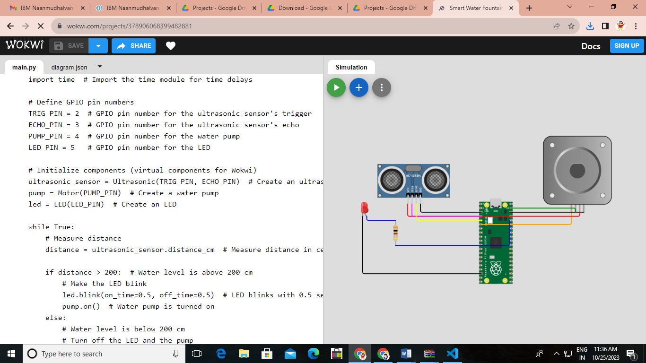

import time  # Import the time module for time delays

# Define GPIO pin numbers

TRIG_PIN = 2  # GPIO pin number for the ultrasonic sensor's trigger

ECHO_PIN = 3  # GPIO pin number for the ultrasonic sensor's echo

PUMP_PIN = 4  # GPIO pin number for the water pump

LED_PIN = 5   # GPIO pin number for the LED

# Initialize components (virtual components for Wokwi)

ultrasonic_sensor = Ultrasonic(TRIG_PIN, ECHO_PIN)  # Create an ultrasonic sensor

pump = Motor(PUMP_PIN)  # Create a water pump

led = LED(LED_PIN)  # Create an LED

while True:

    # Measure distance

    distance = ultrasonic_sensor.distance_cm  # Measure distance in centimeters

    if distance > 200:  # Water level is above 200 cm

        # Make the LED blink

        led.blink(on_time=0.5, off_time=0.5)  # LED blinks with 0.5 seconds on and off time

        pump.on()  # Water pump is turned on

    else:

        # Water level is below 200 cm

        # Turn off the LED and the pump

        led.off()

        pump.off()

    # Introduce a small delay to control the loop rate

    time.sleep(0.1)  # Sleep for 0.1 seconds